**Data Science SQL**

**Mini-Project 1**

**Insight number .1**

**-- FIND ALL THE LIST OF THE CARS WHERE SELLING PRICE IS STARTING FROM DATABASE**

**Query--**

**SELECT \***

**FROM CARS24**

**ORDER BY SELLING_PRICE;**

**Output--**

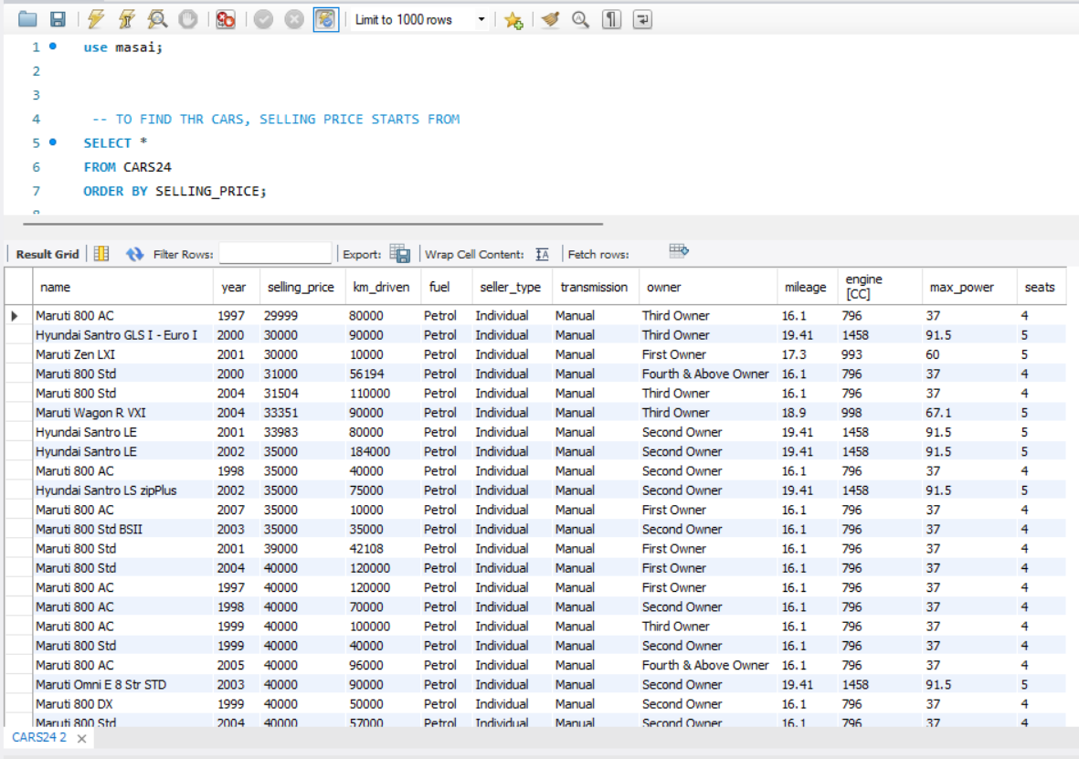

**Insight number .2**

**--- GET CARS STOCK IN THE YEAR 2018**

**Query--**

**SELECT \***

**FROM CARS24**

**WHERE YEAR = 2018;**

**Output--**

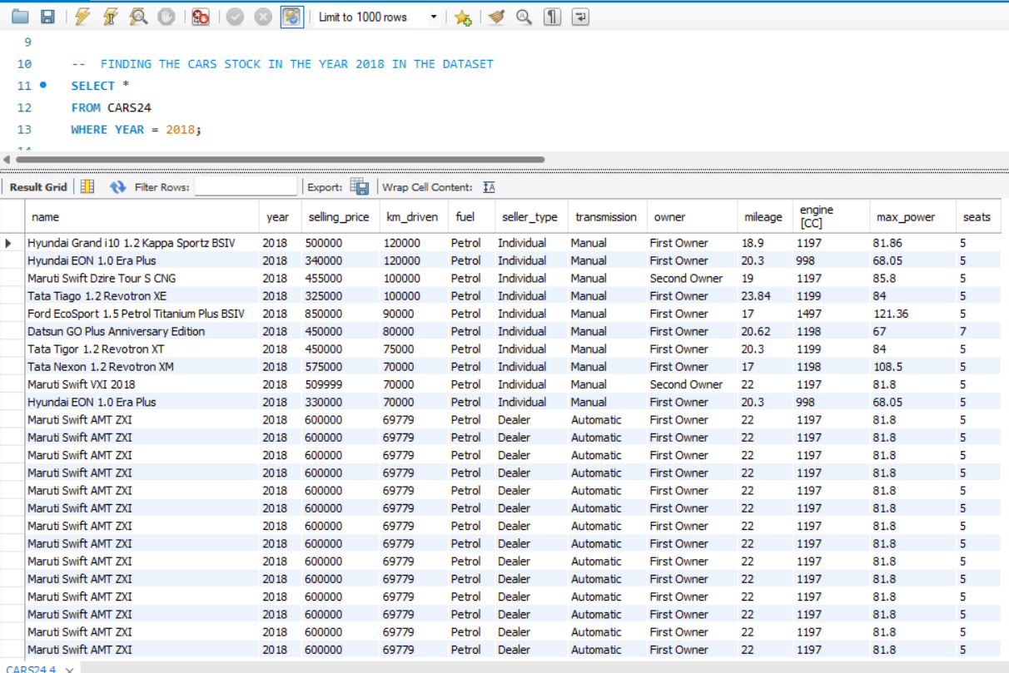

**Insight number .3**

**--- GET THE CAR WHICH HAVE MAXIMUM NO. OF THE PRICE, AND SORT IT IN DESCENDING ORDER OF THE AMOUNT**

**Query--**

**SELECT NAME, MAX(SELLING_PRICE) AS MAX_AMOUNT**

**FROM CARS24**

**GROUP BY NAME**

**ORDER BY MAX_AMOUNT DESC;**

**Output--**

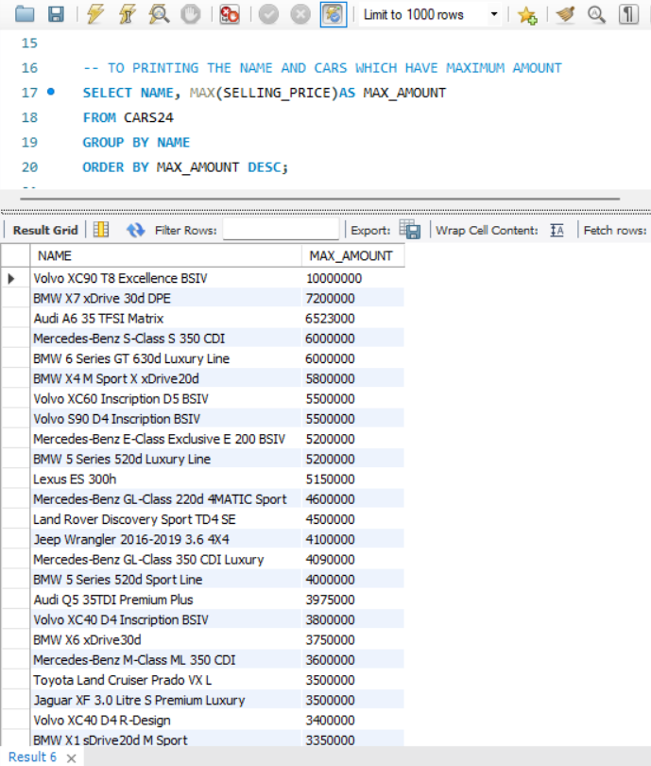

**Insight number .4**

**--- HOW MANY CARS SOLD TO DEALER IN THE YEAR 2015**

**Query--**

**SELECT COUNT(SELLER_TYPE) AS CARS_SOLD_TO_DEALER**

**FROM CARS24**

**WHERE SELLER_TYPE = 'DEALER'**

**AND YEAR = 2015;**

**Output--**

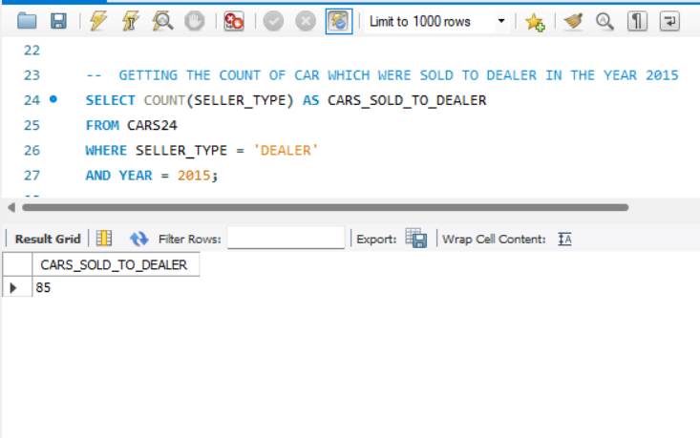

**Insight number. 5**

**--RETRIVE THE CAR'S PRICE RANGE BETWEEN 10 LAKH TO 20 LAKHS. AND ORDER THE RESULT IN ASCENDING ORDER FROM CARS24**

**Query--**

**SELECT * FROM CARS24**

**WHERE SELLING_PRICE**

**BETWEEN 1000000 AND 2000000**

**ORDER BY NAME;**

**Output--**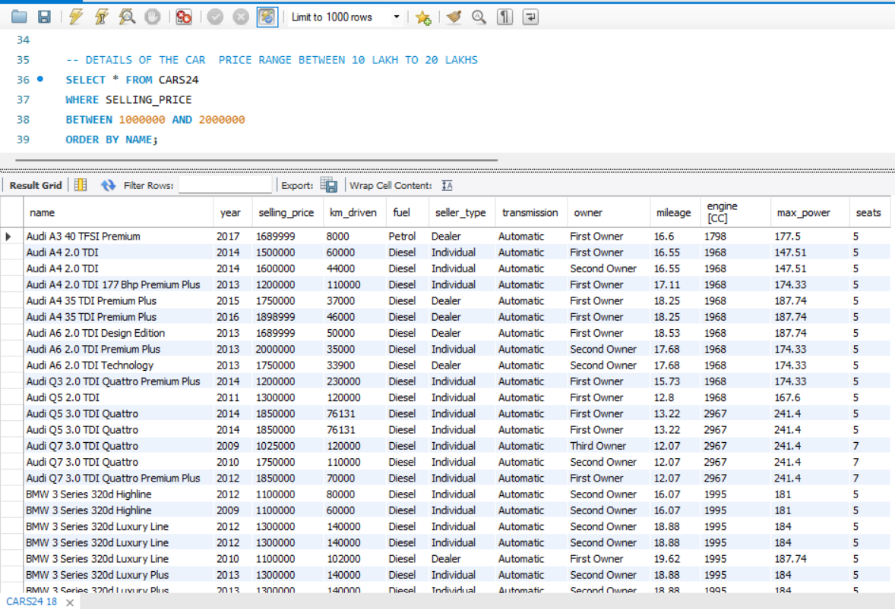

**Insight number. 6**

**--TOP 5 EXPENSIVE CARS IN DATABASE. PRINT NAME OF THE CAR, YEAR, FUEL, KM_DRIVEN, TRANSMISSION, OWNER, MILEAGE AND SEATS OF THE CAR.**

**Query--**

**SELECT NAME, YEAR, FUEL, KM_DRIVEN, TRANSMISSION, OWNER, MILEAGE, SEATS,**

**MAX(SELLING_PRICE) AS TOP_5_EXPENSIVE_CAR**

**FROM CARS24**

**GROUP BY NAME, YEAR, FUEL, KM_DRIVEN, TRANSMISSION, OWNER, MILEAGE, SEATS**

**ORDER BY TOP_5_EXPENSIVE_CAR DESC**

**LIMIT 5;**

**Output--**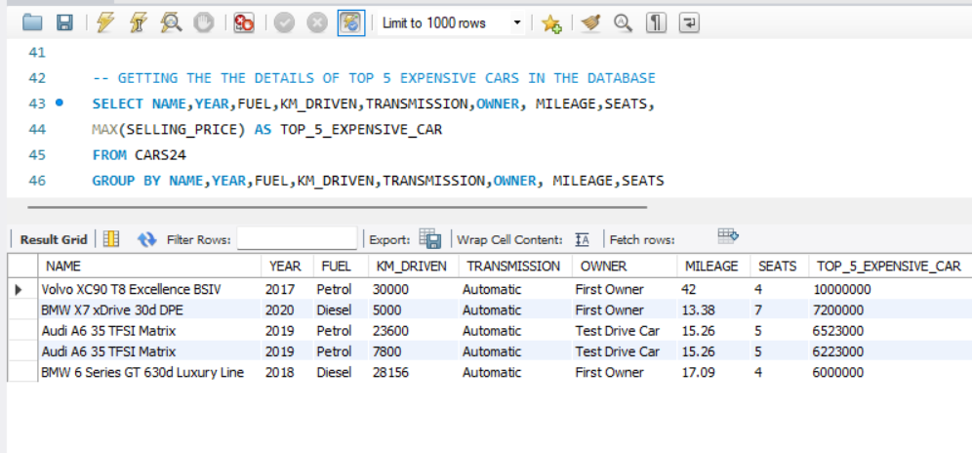

**Insight number. 7**

**--DETAILS OF THE MANUAL CNG CAR WHICH CONTAIN 5 SEATS, MILEAGE IS BETWEEN 15 TO 25 AND SORT RESULT ASCENDING ORDER OF NAME**

**Query--**

**SELECT * FROM CARS24**

**WHERE FUEL = 'CNG'**

**AND MILEAGE BETWEEN 15 AND 25 AND SEATS = 5**

**AND TRANSMISSION = 'MANUAL'**

**ORDER BY NAME, MILEAGE;**

**Output--**

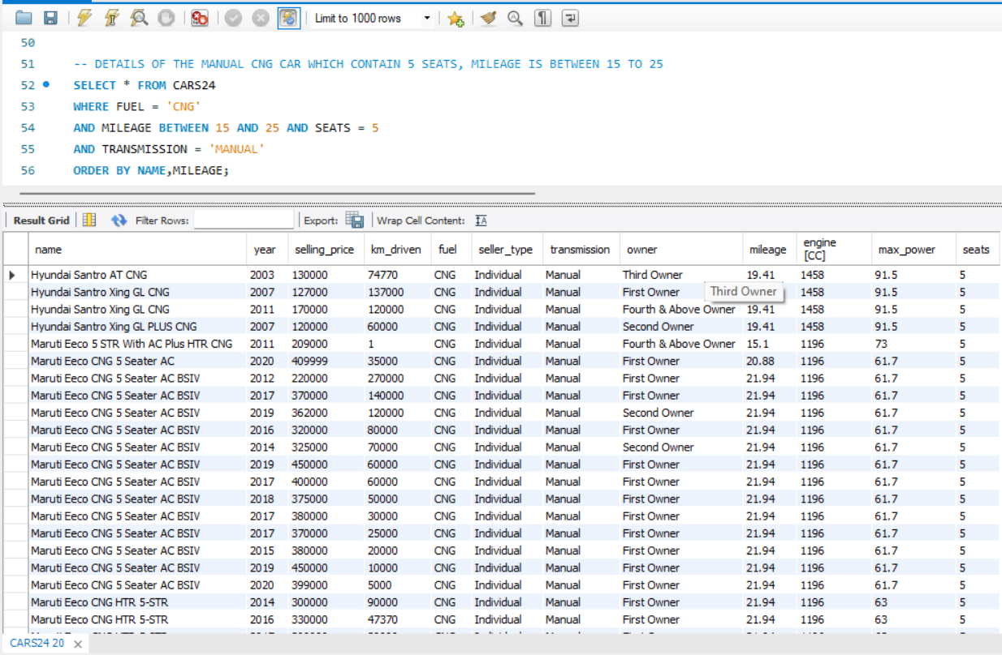

**Insight number. 8**

**--GET THE TOP 10 CARS WHICH HAVE MAXIMUM SPEED. PRINTNAME, YEAR, SELLING_PRICE, KM_DRIVEN,FUEL,MILEAGE,TRANSMISSION,SEATS, AND ORDER IT IN DESCENDING ORDER OF THE MAXIMUM SPEED.**

**Query--**

**SELECT NAME, YEAR, SELLING_PRICE, KM_DRIVEN,FUEL,MILEAGE,TRANSMISSION,SEATS,**

**MAX(MAX_POWER) AS MAX_SPEED**

**FROM CARS24**

**GROUP BY NAME,YEAR,SELLING_PRICE,KM_DRIVEN,FUEL,MILEAGE,TRANSMISSION,SEATS**

**ORDER BY MAX_SPEED DESC**

**LIMIT 10;**

**Output--**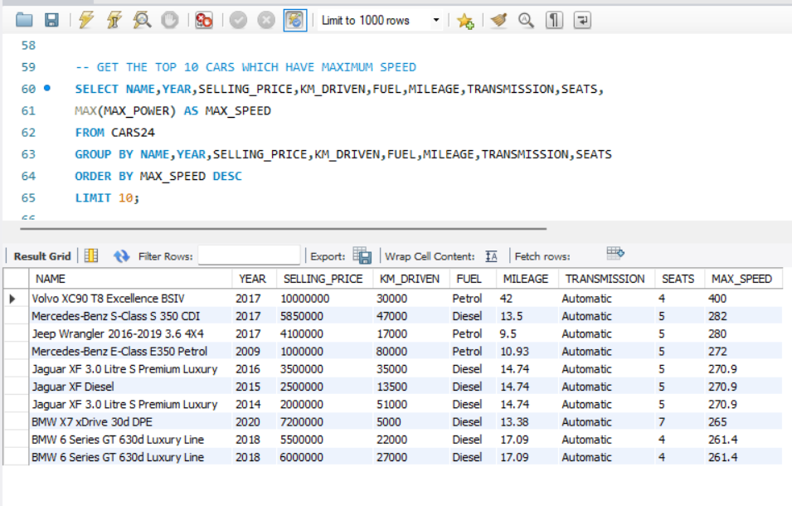

**Insight number. 9**

**---IDENTIFY THE NUMBER OF THE CAR, IF THE MILEAGE OF A CAR IS LESSTHAN 15 THEN CATEGORIZE IT AS 'LOW MILEAGE', IF THE MILEAGE OF THE CAR IS BETWEEN 15-25 THEN IT IS 'AVERAGE MILEAGE', IF THE MILEAGE OF THE CAR IS MORE THAN 25 THEN CATEGORIZE IT 'GOOD MILEAGE CAR' FROM THE CARS24 DATASET.**

**Query--**

**select case**

**when (MILEAGE) < 15 Then 'LOW MILEAGE'**

**when (MILEAGE) between 15 and 25 Then 'AVERAGE MILEAGE'**

**Else 'GOOD MILEAGE'**

**End as MILEAGE_OF_CAR,**

**COUNT(NAME) AS NO_CARS**

**from CARS24**

**group by MILEAGE_OF_CAR;**

**Output--**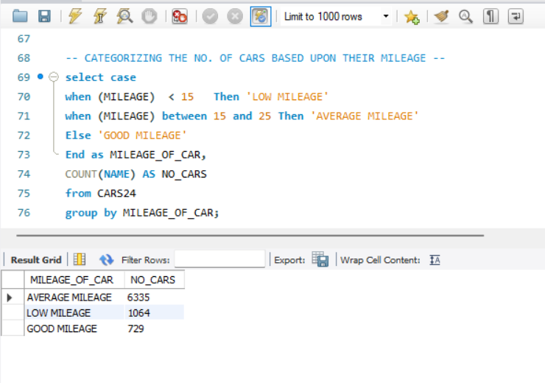

**Insight number. 10**

**CATEGORIZE THE 3 COLUMNS THAT**

**1)No. of VOLVO COMPANY CARS WHICH HAVE AUTO GEAR**

**2)NO. of MERCEDES COMPANY CARS WHICH CONTAIN AUTOGEAR, THEN CATEGORIZE LAST COLUMN AS ALL THE OTHER CARS, SORT THE RESULT INTO ASCENDING ORDER OF THE N0. of CARS.**

**Query--**

**SELECT CASE**

**WHEN (NAME) LIKE '%VOLVO%' AND (TRANSMISSION) = 'AUTOMATIC' THEN 'VOLVO CAR'**

**WHEN (NAME) LIKE '%MERCEDES%' AND (TRANSMISSION) = 'AUTOMATIC' THEN 'MERCEDES-BENZ CAR'**

**ELSE 'OTHER CAR'**

**END AS COMPANY,**

**COUNT (*) AS NO_OF_CARS**

**FROM CARS24**

**GROUP BY COMPANY**

**ORDER BY NO_OF_CARS;**

**Output--**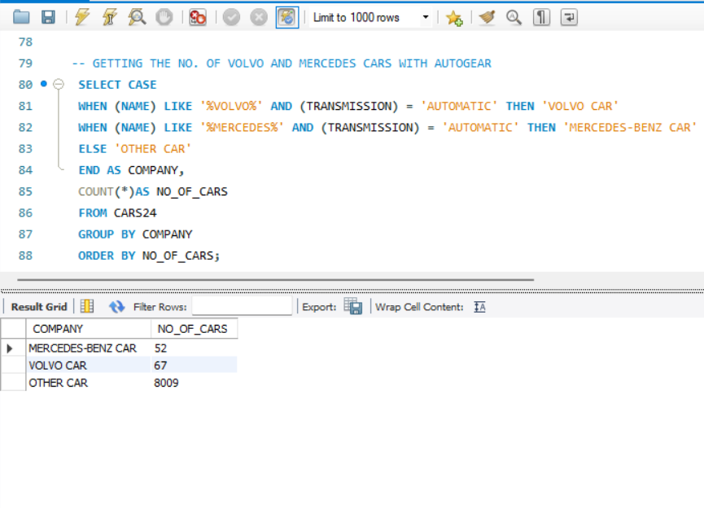

**Insight number. 11**

**--FIND IN WHICH YEAR MAXIMUM CAR HAVE SOLD**

**Query--**

**SELECT max(year)**

**FROM CARS24;**

**Output--**

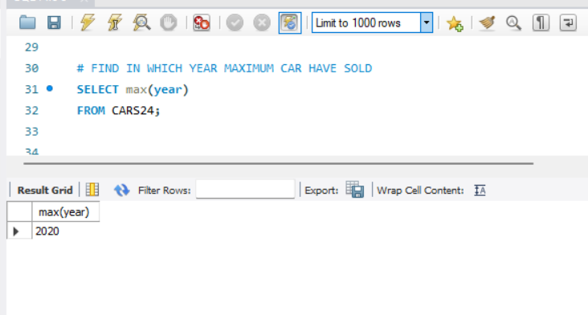

**Insight number. 12**

**-- Get the top 8 cars of Jaguar car which has maximum power**

**Query--**

**select * from cars24**

**where max_power > 100 and name like "%Jaguar%"**

**order by max_power desc**

**limit 8**

**Output--**

